Develop an application which controls a 4 square long worm, controllable using the arrow keys – left (), right (), up() and down (). The effect of pressing the arrow keys is the change in direction of the head of the worm – if it is not the same as the current direction – and a one square advance, if possible. When the direction of the head changes, the body of the worm must pass through the position where the direction change command was given. The area where the worm moves is a 7 by 7 square board. The worm cannot escape the board area, i.e. the margins of the board act as walls. The board is grey; the worm head (one square) is yellow and its body (the other four squares) is pink. The worm is initially in the position shown in the figure below. If the worm cannot move in the desired direction a red square labeled "Bad move" with white letters should be displayed in the area currently labeled "All right" (where the background is usually light green). The arrow key pressed has no effect in those situations.
Start state |  | Step 1. After pressing ↑ |  | Step 2. After pressing 
 | All right |  | All right |  | All right
Step 3. After pressing ↑ |  | Step 4. After pressing ← |  | Step 5. After pressing ↓
 | Bad move! |  | All right |  | All right

Develop an applet which controls a game played on a normal chessboard (i.e. 8 ×8 squares). There are three figures on the chessboard: two white bishops, colored yellow for visibility, symbolized by the capital letter 'B' and a black queen, here colored blue for visibility, symbolized by the letter 'Q'. The bishops are initially located t d4 and g4, and the rook at g8. The squares should be colored light grey (for white), and dark grey (for black), due to visibility concerns. At each push of one of the two buttons, labeled "Bishop" and "Queen", respectively, the corresponding chess figure will make one move, with a random number of squares, according to the rules of the chess game (i.e. the bishops can move only diagonally on squares having the same color as the one they were initially placed on; the queen can move on the line or column it currently is located, and also like the bishops). When two or more figures get on the same square, the one who got there first wins the position eliminating the late figure from the board. The game ends when either the queen or the two bishops rule the board. Then the buttons must be rendered inactive.
A sample chessboard showing the chess algebraic notation | The start position
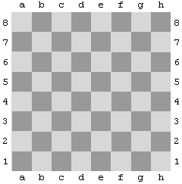
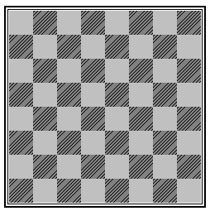
B
B
Q
Queen
Bishop

